A Project Report on

**DETECTING FAKE NEWS USING MACHINE LEARNING**

Submitted in partial fulfillment of the requirements for the award of the degree of

**BACHELOR OF TECHNOLOGY**

in

**COMPUTER SCIENCE AND ENGINEERING**

**Gumpena Veera Durga Jyothi (19P31A0588)**

**Pogiri Sai Lakshmi (19P31A05A5)**

**Barsha Gupta (19P31A0572)**

Submitted by

**Shravan S (19P31A05B0)**

**Under the esteemed supervision of**

**Dr.R.V.S.LALITHA, M.Tech, Ph.D**

**Professor**



**ADITYA COLLEGE OF ENGINEERING & TECHNOLOGY**

**Approved by AICTE, New Delhi & Affiliated to JNTUK, Kakinada**

**Accredited by NAAC (A+) and NBA**

**Surampalem, Kakinada District, Andhra Pradesh - 533 437**

**2019-2023**





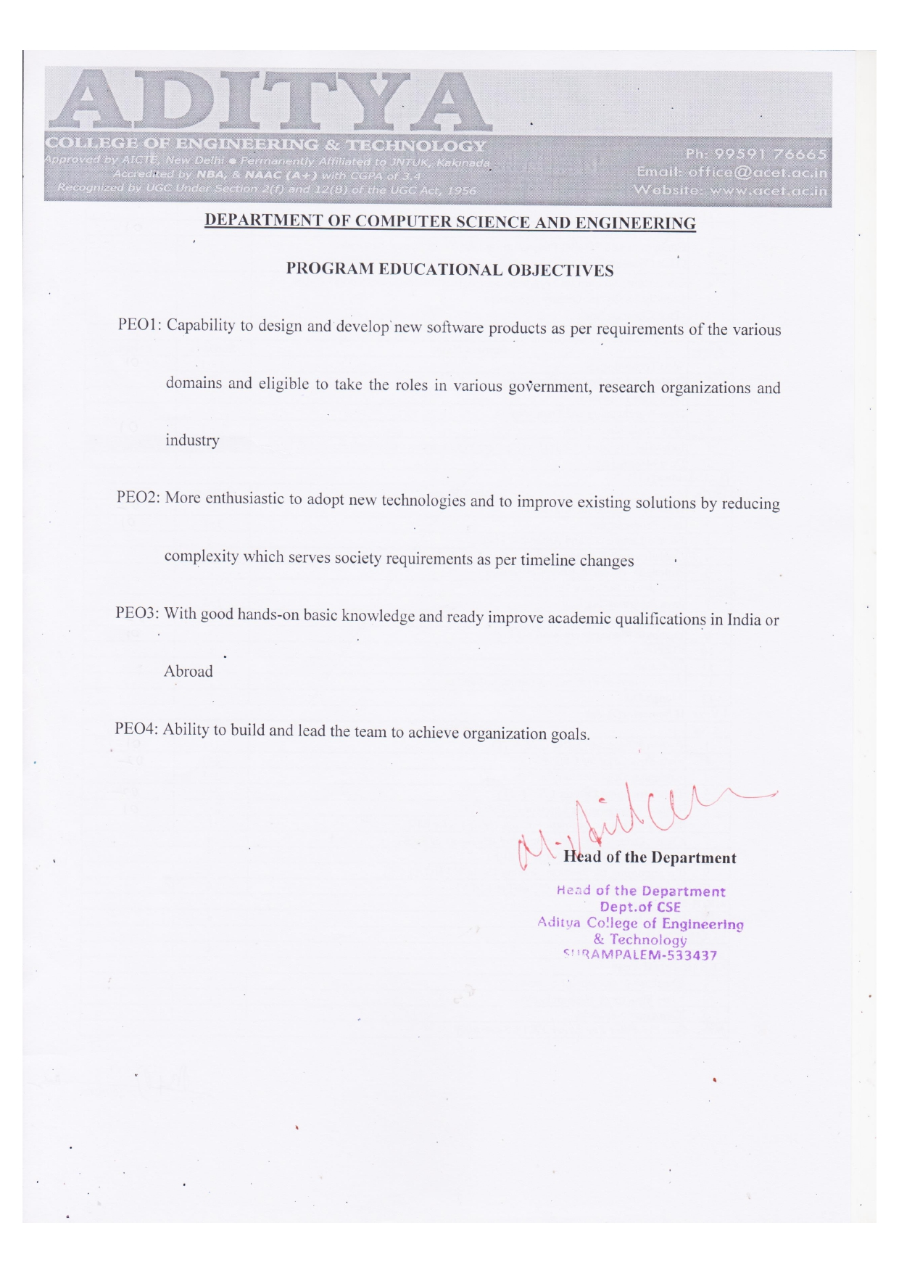

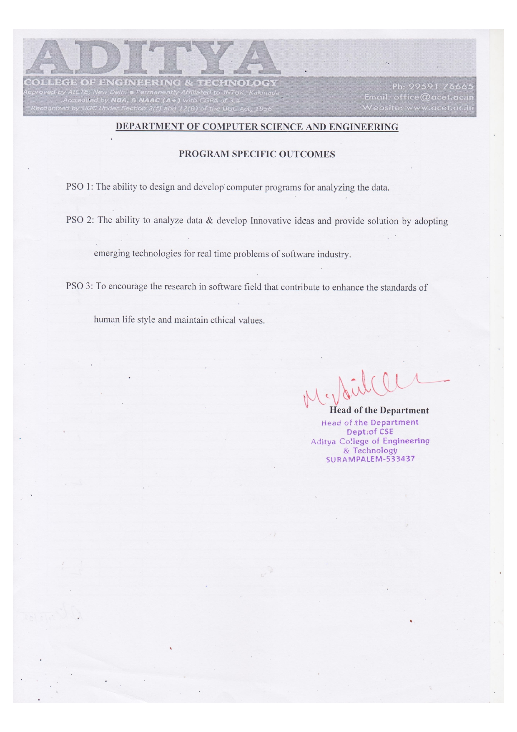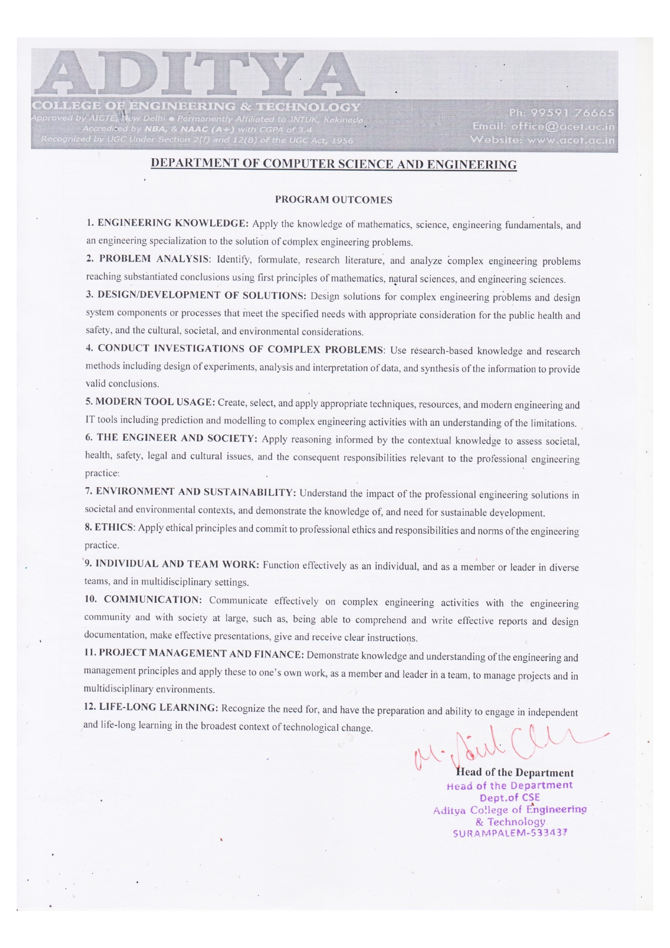

**ADITYA COLLEGE OF ENGINEERING & TECHNOLOGY**

Approved by AICTE, New Delhi & Affiliated to JNTUK, Kakinada

Accredited by NAAC (A+) and NBA

**DEPARTMENT OF COMPUTER SCIENCE AND ENGINEERING**



**CERTIFICATE**

This is to certify that the project work entitled, **"DETECTING FAKE NEWS USING MACHINE LEARNING",** is a bonafide work carried out by **Gumpena Veera Durga Jyothi (19P31A0588), Pogiri Sai Lakshmi (19P31A05A5), Barsha Gupta(19P31A0572), Shravan S(19P31A05B0)**, in partial fulfillment of the requirements for the award **of the degree of BACHELOR OF TECHNOLOGY** in **COMPUTER SCIENCE AND ENGINEERING** from **Aditya College of Engineering and Technology**, Surampalem, during the academic year 2022-2023.

This project work has not been submitted in full or part to any other University or educational institute for the award of any degree or diploma.

|  |  |  |
| --- | --- | --- |
| **PROJECT SUPERVISOR**  Dr.R.V.S.Lalitha,M.Tech.,Ph.D.  Professor |  | **HEAD OF THE DEPARTMENT**  Dr.M.Anil Kumar, M.Tech., Ph.D.  Professor |

**EXTERNAL EXAMINER**

**DECLARATION**

We here by declare that this project entitled **"DETECTING FAKE NEWS USING MACHINE LEARNING"** has been undertaken by us and this work has been submitted to **ADITYA COLLEGE OF ENGINEERING AND TECHONOLOGY,** Surampalem affiliated to JNTUK, Kakinada, in partial fulfillment of the requirements for the award of the degree of **BACHELOR OF TECHNOLOGY** in **COMPUTER SCIENCE AND ENGINEERING.**

We further declare that this project work has not been submitted in full or part to any other University or educational institute for the award of any degree or diploma.

|  |  |
| --- | --- |
| **PROJECT ASSOCIATES**  **Gumpena Veera Durga Jyothi (19P31A0588)**  **Pogiri Sai Lakshmi (19P31A05A5)**  **Barsha Gupta (19P31A0572)**  **Shravan S (19P31A05B0)** | |
|  |  |

|  |
| --- |
|  |
|  |

**ACKNOWLEDGEMENT**

It is with immense pleasure that we would like to express our indebted gratitude to my **project supervisor**, **Dr.R.V.S.Lalitha,M.Tech.,Ph.D.** who has guided us a lot and encouraged us in every step of project work, his valuable moral support and guidance has been helpful in successful completion of this Project.

We wish to express our sincere thanks to **Dr. M. ANIL KUMAR M.Tech. ,Ph.D.,** **Head of the Department of CSE**, for his valuable guidance given to us throughout the period of the project work.

We feel elated to thank **Principal**, **Dr. DOLA SANJAY S M.Tech., Ph.D.**, of Aditya College of Engineering and Technology for his cooperation in completion of our project and throughout our course.

We feel elated to thank **Dr.A.RAMA KRISHNA M.Tech.,Ph.D.**, **Dean (Academics & Administration)** of Aditya College of Engineering and Technology for his cooperation in completion of our project work.

We wish to express our sincere thanks to all faculty members, and lab programmers for their valuable guidance given to us throughout the period of the project.

We avail this opportunity to express our deep sense and heart full thanks to the **Management** of **Aditya College of Engineering & Technology** for providing a great support for us by arranging the trainees, and facilities needed to complete our project and for giving us the opportunity for doing this work.

|  |  |
| --- | --- |
| **PROJECT ASSOCIATES**  **Gumpena Veera Durga Jyothi (19P31A0588)**  **Pogiri Sai Lakshmi (19P31A05A5)**  **Barsha Gupta (19P31A0572)**  **Shravan S (19P31A05B0)** | |
|  |  |
|  |  |
|  |  |

**ABSTRACT**

In our modern era where the internet is ubiquitous, everyone relies on various online resources for news. Along with the increase in the use of social media platforms like Facebook, Twitter, etc. news spread rapidly among millions of users within a very short span of time. The spread of fake news has far-reaching consequences like the creation of biased opinions to swaying election outcomes for the benefit of certain candidates. Moreover, spammers use appealing news headlines to generate revenue using advertisements via click baits. It is harmful for the society to believe on the rumors and pretend to be a news. The need of an hour is to stop the rumors especially in the developing countries like India, and focus on the correct, authenticated news articles. Fake news detection is used to avoid rumors from spreading across various platforms, such as social media and messaging platforms. so, we aim to perform binary classification of various news articles available online with the help of concepts pertaining to Artificial Intelligence, Natural Language Processing and Machine Learning. We aim to provide the user with the ability to classify the news as fake or real and also check the authenticity of the website publishing the news. This model requires

prerequisite data extracted from various news websites. Web scraping technique is used for data extraction which is further used to create datasets. The data is classified into two major categories which are true dataset and false dataset. Classifiers used for the classification of data is Logistic Regression. Based on the output received the data is classified either as true or false data. Based on that, the user can find out whether the given news is fake or not on the webserver.

**Keywords:** Fake news detection, Logistic Regression classification, machine learning, web scraping, Feature Extraction, TF-IDF vectorization.

|  |  |
| --- | --- |
| **INDEX** |  |
| **CHAPTER** | **PAGE** |
| **ABSTRACT** | **1** |
| **1.INTRODUCTION** | **5** |
| 1.1 Objective of Research | 5 |
| 1.2 Proposed System | 6 |
| 1.3 Novelty of Proposed System | 6 |
| 1.4 Problem Statement | 6 |
| 1.5 Working of WebScraping | 7 |
| **2.RELATED WORK** | **8** |
| 2.1 Software Requirements | 8 |
| 2.2 Functional Requirements | 9 |
| 2.3 Non-Functional Requirements | 9 |
| 2.3.1 User Interface | 10 |
| 2.3.2.Software Requirements | 10 |
| 2.2.3 Hardware Requirements | 10 |
| 2.2.4 Performance | 10 |
| 2.2.5 Usability | 11 |
| 2.2.6 Reliability | 11 |
| 2.2.7 Scalability | 11 |
| **3.LITEREATURE SURVEY** | **12** |
| 3.1 An overview of paper-1 | 12 |
| 3.2 An overview of paper-2 | 13 |
| **4.METHODOLOGY** | **15** |
| 4.1 System Architecture | 15 |
| 4.2 Block Diagram of Proposed System | 19 |
| 4.3 System Design | 20 |
| 4.3.1 Data Flow Diagram | 20 |
| **5.RESULT AND DISCUSSION** | 21 |
| 5.1 Source Code | 22 |
| 5.2 Evaluation Matrices | 32 |
| 5.3 confusion Matrix | 32 |
| 5.4 Output Screenshots | 33 |
| **6.BASE PAPERS** | 37 |
| **7.POWER POINT PRESENTATION SLIDES** | 47 |
| **CONCLUSION** | 54 |
| **BIBLIOGRAPHY** | 55 |

**LIST OF FIGURES**

|  |  |  |
| --- | --- | --- |
| **S.NO.** | **NAME OF FIGURE** | **PAGE NO.** |
| 1 | 1.5.1 Web Scraping | 7 |
| 2 | 3.2 Different approaches to detect | 12 |
| 3 | 4.1 System Architecture | 15 |
| 4 | 4.2 Block Diagram | 19 |
| 5 | 4.2.1 Static Search | 19 |
| 6 | 4.3.1 Data Flow Diagram | 20 |
| 7 | 5 True and fake dataset | 21 |

8 5.1 Jupyter Interface 22

9 5.1.2 Heat Map 27

10 5.4.3 Topic wise Distribution 36

**1.INTRODUCTION**

In Today's world, anybody can post the content over the internet. Unfortunately, counterfeit news gathers a lot of consideration over the web, particularly via web-based networking media. Individuals get misdirected and don't reconsider before flowing such mis-educational pieces to the most distant part of the arrangement. Such type of activities are not good for the society where some rumors or vague news evaporates the negative thought among the people or specific category of people. As fast the technology is moving, on the same pace the preventive measures are required to deal with such activities. Broad communications assuming a gigantic job in impacting the general public and as it is normal, a few people attempt to exploit it. There are numerous sites which give false data. They deliberately attempt to bring out purposeful publicity, deceptions and falsehood under the pretense of being true news. Their basic role is to control the data that can cause open to have confidence in it. There are loads of case of such sites everywhere throughout the world .Therefore, counterfeit news influences the brains of the individuals. As indicated by study Scientist accept that numerous man-made brainpower calculations can help in uncovering the bogus news. Fake news detection is made to stop the rumors that are being spread through the various platforms whether it be social media or messaging platforms, this is done to stop spreading fake news which leads to activities like mob lynching, this has been a great reason motivating us to work on this project. We have been continuously seeing various news of mob lynching that leads to the murder of an individual; fake news detection works on the objective of detecting this fake news and stopping activities like this thereby protecting the society from these unwanted acts of violence. The main objective is to detect the fake news, which is a classic text classification problem with a straight forward proposition. It is needed to build a model that can differentiate between “Real” news and “Fake” news. This leads to consequences in social networking sites like Facebook, Instagram, microblogging sites like Twitter and instant messaging applications like WhatsApp, Hike where these fake news gets a major boost and gets viral among people, around the country and globe. The proposed system helps to find the authenticity of the news. If the news is not real, then the user is suggested with the relevant news article.

* 1. **Objective of Research:-**

The most common algorithms used by fake news detection systems include machine learning algorithms such as Sup port Vector Machines, Random Forests, Decision trees, Sto chastic Gradient Descent, Logistic Regression and so on. In this project have attempted to implement one out of these algorithms to train and test our results to attain the maximum accuracy using logistic algorithm with webScraping technique(Beautiful Soup).

**1.2 Proposed System:-**

The term ‘Fake news’ refers to the news content that is false, misleading, or fabricated, in which the facts, sources, or quoted statements of the news content are unverified. Fake news has existed in the form of gossip, rumor, and misinformation throughout human history.To increase its effectiveness this Fake news is spread throughout social media. Along with the billions of people using social media, there are also robots, or simply bots, residing within. These Bots help to propagate fake news faster and boost up its popularity on social media Fake news detection is used to avoid rumors from spreading across various platforms, such as social media and messaging platforms. The impetus for this work is to avoid the spread of Fake-news which can even lead to worse activities. There has been a rise in the news lately about lynchings and riots that result in mass deaths; fake news detection aims to detect these and stop similar activities, thereby protecting society from these unwelcome violent acts . The proposed system helps to find the authenticity of the news. The news given by the user is classified as true or false based on the data collected using Web Scraping (ParseHub/Beautiful Soup). This task uses Logistic Regression classification model. To improve prediction accuracy.

**1.3 Novelty of proposed system:-**

In this project we will collect data using web scraping (ParseHub) tool and uses Logistic Regression Classification model to get high accuracy. Web Scraping refers to the extraction of content and data from a website. This information is then extracted in a format that is more useful to the user. Web Scraping can be done manually, but this is extremely tedious work. To speed up the process you can use Web Scraping Tools that would be automated, cost less, and work more swiftly.

**1.4 Problem statement :-**

From the last few years, the use of social media has increased resulting into the rise of fake news and their spreading on a large scale. Recent political events have increased the spread of fake news. As seen by the widespread impact of the huge beginning of fake news, people are inconsistent in the absence of effective fake news detectors. This work has made an attempt to automate the fake news detection process by employing the logistic regression (LR) and webscraping.

**1.5 Working of Web Scrapping:-**

First, the Web Scraper is given the URLs to load up before the scraping process. The scraper then loads the complete HTML code for the desired page.   The Web Scraper will then extract either all the data on the page or the specific data selected by the user before running the project. Finally, the Web Scraper outputs all the data that has been collected into a usable format.



**Fig:1.5.1 Web Scraping**

**2.RELATED WORK**

In Existing System, to detect whether the news is fake or real they use Naïve Bayes . A Naive Bayes classifier is a supervised machine learning algorithm that uses Bayes‟ Classifier theorem. The variables that are used to generate the model are independent of each other. It is proven that this classifier itself provides pretty good results.

(( |𝐶𝑖) =π 𝑃( 𝑥𝑘|𝐶𝑖) = 𝑃 (𝑥1|𝐶𝑖) ×𝑃( 𝑥2 |𝐶𝑖) × … × 𝑃( 𝑥𝑛| 𝐶𝑖)

The classification is conducted by deriving the maximum posterior, which is the maximal P(Ci |X) with the above assumption applying to Bayes theorem. This assumption greatly reduces the computational cost by only counting the class distribution. Naive Bayes is popular algorithm which is used to find the accuracy of the news whether its real or fake using multinomial Naïve Bayes. There are number of algorithms that focus on common principle, so it is not the only algorithm for training such classifiers. Random Forest is a popular machine learning algorithm that belongs to the supervised learning technique. It can be used for both Classification and Regression problems in ML. It is based on the concept of **ensemble learning,** which is a process of combining multiple classifiers to solve a complex problem and to improve the performance of the model.As the name suggests, ***"*Random Forest is a classifier that contains a number of decision trees on various subsets of the given dataset and takes the average to improve the predictive accuracy of that dataset*."*** Instead of relying on one decision tree, the random forest takes the prediction from each tree and based on the majority votes of predictions, and it predicts the final output.**The greater number of trees in the forest leads to higher accuracy and prevents the problem of overfitting.** To check if the news is fake or real naïve Bayes and random forest are used. By using this Navie Bayes and random forest theorem the accuracy is low. So ,we are using Logistic Regression algorithm to get high accuracy.

**2.1 Software Requirements**

Equipment Interfaces the application is planned to be an independent, single-client framework. The application will run on a laptop. No further equipment gadgets or connection points will be required.

[1] Programming Interfaces

[2] Inputs the product will get input from One source. To start with, the UI. The UI will supply the Text and the investigation meeting.

[3] Yields the result will be text format.

[4] Working System.

[5] UIs The point of interaction will meet the accompanying necessities to adjust to the clients' requirements. It will be basic and straightforward. Controls which permit the client to interface with the application will be clear and infer their usefulness inside the application. The connection point will incorporate client inputs just as two illustrations, laid out underneath.

**2.2 Functional Requirements:-**

* Take a news article URL from user.
* Extract relevant text from the URL, provided by the user, using Scrapy, Beautiful soup.
* Then we will extract relevant features from the text using NLP (Natural Language Processing).
* Correctly classify news article as fake news or credible news using different machine learning models/algorithms.We can classified a given news article fake or real.
* We can then modify our classification if needed and add the news article in the training set to improve accuracy of future predictions.

**2.3 Non-Functional Requirements:-**

[1]The exhibition of the capacities and each module should be well.

[2] The general exhibition of the product will empower the clients to work productively.

[3] Execution of reaction ought to be quick.

[4] Execution of the giving virtual climate ought to be quick.

[5] Wellbeing Requirement-The application is planned in modules where mistakes can be recognized and fixed without any problem. This makes it simpler to introduce and refresh new usefulness whenever required.

[6] Programming Quality Attributes-Our product has numerous quality characteristic that are given beneath:-

• Flexibility: This product is versatile by all clients.

• Accessibility: This product is uninhibitedly accessible to all clients. The accessibility of the product is simple for everybody.

• Practicality: After the organization of the venture assuming any blunder happens then it tends to be handily kept up with by the product designer.

• Dependability: The exhibition of the product is better which will build the unwavering quality of the Software.

• Ease of use: Since, the product is a GUI application; the result created is a lot of easy to understand in its conduct.

• Trustworthiness: Integrity alludes to the degree to which admittance to programming or information by unapproved people can be controlled.

• Security: Users are validated utilizing numerous security stages so solid security is given.

• Test-capacity: The product will be tried thinking about every one of the viewpoints.

**2.3.1 User Interface:-**

The user interface will be web based provided to user through a web browser then user will presented with a dashboard. The dashboard will consist of a header, sidebar menu and body. The body will be consisting of dialogue box which will be used to get the input from user. There will be a button to submit the query entered by user in the dialogue box, then it shows the result.

**2.3.2 Software Requirements:-**

* Jupyter
* Web Scraping
* Python programming Language

**2.3.3 Hardware Requirements:-**

* Processor: Intel i3
* Ram:8GB
* Hard disk:100 GB

**2.3.4.Performance Requirements:-**

• The system should respond to a user query and return a result in less than 5 seconds.

• Web crawling should be done in fast time.

• extraction must be done in milliseconds

. • Time taken by ML algorithms should be in milliseconds.

• System should be able to handle multiple simultaneous requests

**2.3.5.Usability**

The main purpose of our project is to detect whether the news is fake or real by using Logistic Regression and webscraping techniques. So that the people can know the real news. The usability of the system must be simple and easy.

**2.3.6.Reliability**

The System must be efficient to use, it will provide accurate result by taking the input as a url it will webscrap the data through the url and predict the result accurately.

**2.3.7.Scalability**

It support more than one person to use at a time.

**3.LITEREATURE SURVEY**

**3.1 An overview of paper-1**

Paper Name: News Labeling as Early as Possible: Real or Fake?

Author Name: Maryam Ramezani, Mina Rafiei, Soroush Omranpour

Description: Fake news is a wonder which is altogether influencing our public movement, explicitly in the political world.Information exactness on Internet, especially through online systems administration media, is an evidently critical concern, but web-scale data hampers, ability to recognize, survey and right such data, or assumed "fake news," present in these stages.The usage of faux information and social media by means of mainstream information channels of India and how they’re the use of social media and fake information to fuel nationalism and create department among communities to avoid essential problems of the USA. like employment, fitness care, training, infrastructure, crime towards girls and children, financial system and many others.The dataset supplied on this paper consists of manually recognized and categorized information stories that can be used for the education and checking out of type systems that discover valid as opposed to fake and manipulative news testimonies.

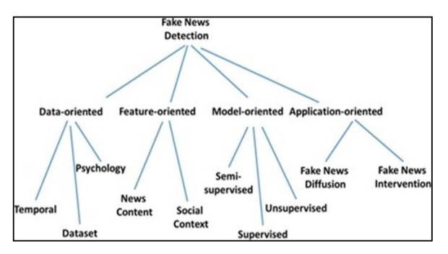

Fig:3.1 Different approaches to detect fake news

**3.2 An overview of paper-2**

Paper name: Detecting Fake News in Social Media Networks

Author name: Monther Aldwairi, Ali Alwahed

Description: Most of the smart phone users prefer to read the news via social media over internet. The news websites are publishing the news and provide the source of authentication. The question is how to authenticate the news and articles which are circulated among social media like WhatsApp groups, Facebook Pages, Twitter and other micro blogs & social networking sites. It is harmful for the society to believe on the rumors and pretend to be a news. The need of an hour is to stop the rumors especially in the developing countries like India, and focus on the correct, authenticated news articles. In Today's world, anybody can post the content over the internet. Unfortunately, counterfeit news gathers a lot of consideration over the web, particularly via web-based networking media. Individuals get misdirected and don't reconsider before flowing such mis-educational pieces to the most distant part of the arrangement. Such type of activities are not good for the society where some rumors or vague news evaporates. Broad communications assuming a gigantic job in impacting the general public and as it is normal, a few people attempt to exploit it. There are numerous sites which give false data.Fake news detection is made to stop the rumors that are being spread through the various platforms whether it be social media or messaging platforms, this is done to stop spreading fake news which leads to activities like mob lynching, this has been a great reason motivating us to work on this project. We have been continuously seeing various news of mob lynching that leads to the murder of an individual; fake news detection works on the objective of detecting this fake news and stopping activities like this thereby protecting the society from these unwanted acts of violence.The main objective is to detect the fake news, which is a classic text classification problem with a straight forward proposition. It is needed to build a model that can differentiate between “Real” news and “Fake” news. This leads to consequences in social networking sites like Facebook, Instagram, microblogging sites like Twitter and instant messaging applications like WhatsApp, Hike where these fake news gets a major boost and gets viral among people, around the country and globe.The proposed system helps to find the authenticity of the news. If the news is not real, then the user is suggested with the relevant news article.WhatsApp Work for Fake News Detection To stop the spread of misinformation, WhatsApp has implemented some security measures and also fake news detection, though these are under alpha phase and are yet to be rolled out to the beta users. WhatsApp testing „Suspicious Link Detection‟ feature: This feature will alert uses by putting a red label on links that it knows to lead to a fake or alternative website/news. Additionally, if a message has been forwarded from a device more than 25 times, the message could be blocked.

Outcome:As mentioned in the above section, all top most giants are trying to hide their selves from the rumors and focus should be on true news and authenticated articles. More or less, the approaches follow in the extraction are based on machine learning and Natural language processing. The classifiers, models and analytical algorithms are required to work hand in hand for the authentication of news articles. New authenticator follows some steps to check whether the news is true or false. It will compare news which is given by our side with different websites and various news sources if that news is found on any news website then it shows the given news is true, else it shows there has been no such news in last few days. This can help us from fake news. These days‟ fake news spread very fast because of social media and the internet. So, news authenticator helps us to detect either the given news is fake or real.It is significant to find the accuracy of news which is available on internet. In the paper, the components for recognizing Fake news are discussed. A mindfulness that not all, the fake news will propagate via web-based networking media.

**4.METHODOLOGY**

**4.1 System Architecture**

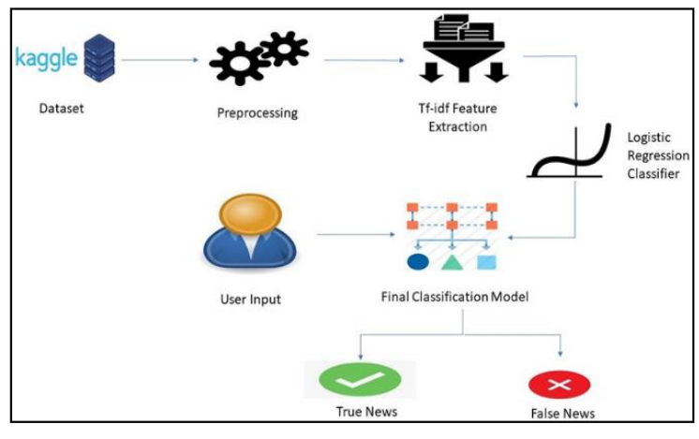

**Fig:4.1 System Architecture**

**Preprocessing:-**

Data preprocessing is a process of preparing the raw data and making it suitable for a machine learning model. It is the first and crucial step while creating a machine learning model.

A real-world data generally contains noises, missing values, and maybe in an unusable format which cannot be directly used for machine learning models. Data preprocessing is required tasks for cleaning the data and making it suitable for a machine learning model which also increases the accuracy and efficiency of a machine learning model.It involves **Getting the dataset, Importing libraries, Importing datasets, Finding Missing Data, Encoding Categorical Data, Splitting dataset into training and test set, Feature scaling.**

**Feature Extraction:-**

Feature Extractions Like news aggregrator which collect news different websites, news authentication that a given news is present or not in our database using sequence matcher form difflib module, news recommendation which gives news recommendation based on our search matching keywords, predictions which use to train our data give result with the given input is fake or real.

**Logistic Regression:-**

* Logistic regression is one of the most popular Machine Learning algorithms, which comes under the Supervised Learning technique. It is used for predicting the categorical dependent variable using a given set of independent variables.
* Logistic regression predicts the output of a categorical dependent variable. Therefore the outcome must be a categorical or discrete value. It can be either Yes or No, 0 or 1, true or False, etc. but instead of giving the exact value as 0 and 1, **it gives the probabilistic values which lie between 0 and 1.**
* Logistic Regression is much similar to the Linear Regression except that how they are used. Linear Regression is used for solving Regression problems, whereas **Logistic regression is used for solving the classification problems.**
* In Logistic regression, instead of fitting a regression line, we fit an "S" shaped logistic function, which predicts two maximum values (0 or 1).
* The curve from the logistic function indicates the likelihood of something such as whether the cells are cancerous or not, a mouse is obese or not based on its weight, etc.
* Logistic Regression is a significant machine learning algorithm because it has the ability to provide probabilities and classify new data using continuous and discrete datasets.
* Logistic Regression can be used to classify the observations using different types of data and can easily determine the most effective variables used for the classification. The below image is showing the logistic function:

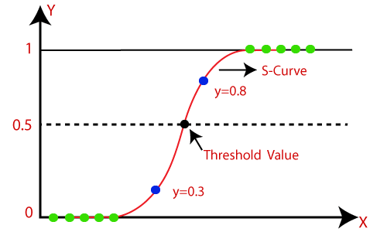

**Fig:Logistic Regression**

**Logistic Function (Sigmoid Function):**

* The sigmoid function is a mathematical function used to map the predicted values to probabilities.
* It maps any real value into another value within a range of 0 and 1.
* The value of the logistic regression must be between 0 and 1, which cannot go beyond this limit, so it forms a curve like the "S" form. The S-form curve is called the Sigmoid function or the logistic function.
* In logistic regression, we use the concept of the threshold value, which defines the probability of either 0 or 1. Such as values above the threshold value tends to 1, and a value below the threshold values tends to 0.

**Assumptions for Logistic Regression:**

* The dependent variable must be categorical in nature.
* The independent variable should not have multi-collinearity.

**Logistic Regression Equation:**

The Logistic regression equation can be obtained from the Linear Regression equation. The mathematical steps to get Logistic Regression equations are given below:

* We know the equation of the straight line can be written as:



* In Logistic Regression y can be between 0 and 1 only, so for this let's divide the above equation by (1-y):

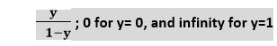

* But we need range between -[infinity] to +[infinity], then take logarithm of the equation it will become:

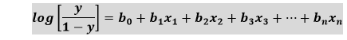

The above equation is the final equation for Logistic Regression.

**Type of Logistic Regression:**

On the basis of the categories, Logistic Regression can be classified into three types:

* **Binomial:** In binomial Logistic regression, there can be only two possible types of the dependent variables, such as 0 or 1, Pass or Fail, etc.
* **Multinomial:** In multinomial Logistic regression, there can be 3 or more possible unordered types of the dependent variable, such as "cat", "dogs", or "sheep"
* **Ordinal:** In ordinal Logistic regression, there can be 3 or more possible ordered types of dependent variables, such as "low", "Medium", or "High".

**Steps in Logistic Regression:**

To implement the Logistic Regression using Python, we will use the same steps as we have done in previous topics of Regression. Below are the steps:

* Data Pre-processing step
* Fitting Logistic Regression to the Training set
* Predicting the test result
* Test accuracy of the result(Creation of Confusion matrix)
* Visualizing the test set result.

**4.2 Block Diagram of Proposed system:-**

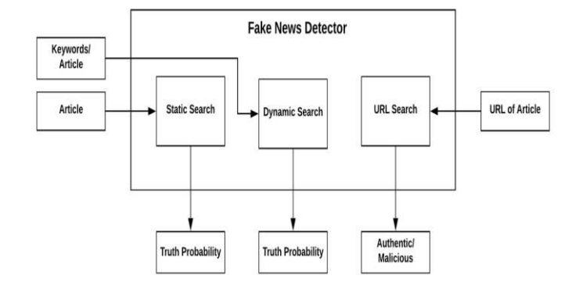

**Fig:4.2 Block Duagram**

**Static Search:-**

The architecture of Static part of fake news detection system is quite simple and is done keeping in mind the basic machine learning process flow. The system design is shown below and self- explanatory. The main processes in the design are

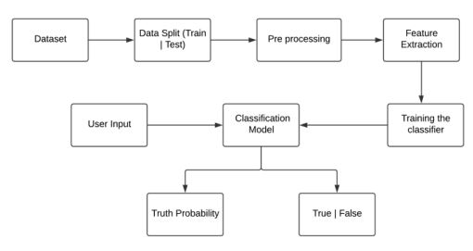

**Fig:4.2.1 Static search**

**Dynamic Search:-**

The second search field of the site asks for specific keywords to be searched on the net upon which it provides a suitable output for the percentage probability of that term actually being present in an article or a similar article with those keyword references in it.

**URL Search:-**

The third search field of the site accepts a specific website domain name upon which the implementation looks for the site in our true sites database or the blacklisted sites database. The true sites database holds the domain names which regularly provide proper and authentic news and vice versa. we will get the data from the websites and we will compare the particular data with our keywords in the dataset, then we can know whether the data is fake or real . If the site isn‘t found in either of the databases then the implementation doesn‘t classify the domain it simply states that the news aggregator does not exist.

**4.3 System Design**

In system design we will consider dataset by doing web scraping using ParseHub tool.web scraping means extraction of the data. Extracting data is exported in JSON or Excel Format. So we consider that data as input and we will preprocess the data, after preprocessing features will be extracted. Then we will use Logistic Regression Classification model(LR) and by using this model ,we will train the classifier after training we will classify the news data whether it is Real or Fake.

**4.3.1 Data Flow Diagram**

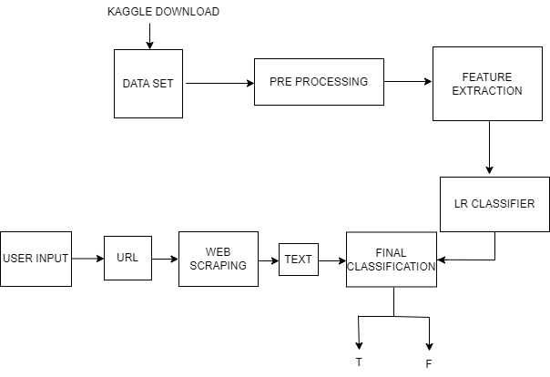

Fig:4.3.1 Data Flow Diagram

**5.RESULTS AND DISCUSSIONS**

The dataset employed here is taken from Kaggle. The dataset consists of two files called as fake and real csv files. The data consists of 44898 rows and 4 columns.

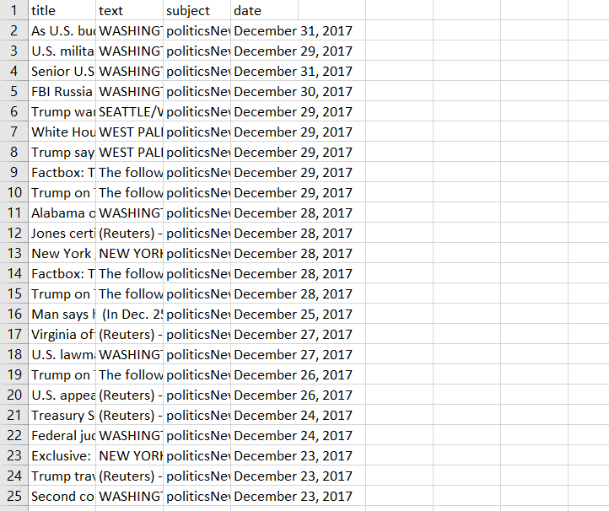

Fig:5True Dataset sample

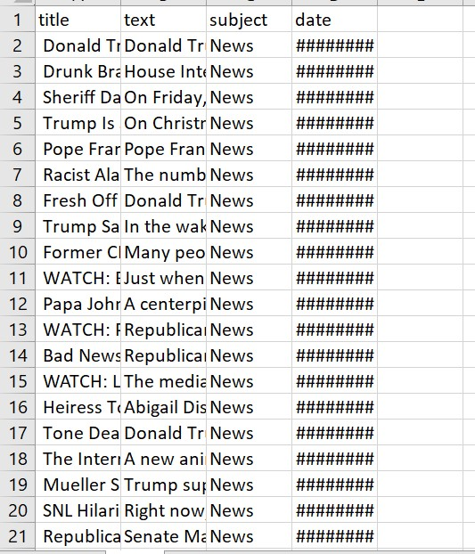

Fig:5 Fake Dataset sample

**5.1 Source** **Code:-**

Now we will start writing the code , we can either write it in our Jupyter Notebook or Google Colab or any other platform we like. Also download the dataset from Kaggle.

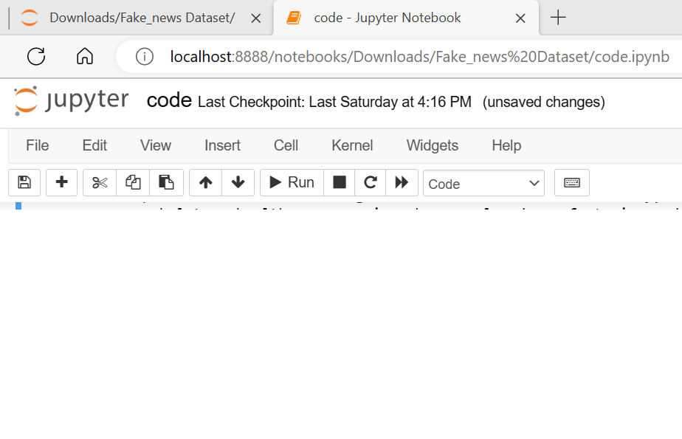  
 fig:5.1 Jupyter Interface

JupyterLab is the latest web-based interactive development environment for notebooks, code, and data. Its flexible interface allows users to configure and arrange workflows in data science, scientific computing, computational journalism, and machine learning. A modular design invites extensions to expand and enrich functionality.

**5.1.1 Importing required library**

import pandas as pd

import numpy as np

import seaborn as sns

import requests

import matplotlib.pyplot as plt

from sklearn.model_selection import train_test_split

from sklearn.metrics import accuracy_score

from sklearn.metrics import classification_report

from bs4 import BeautifulSoup

import re

import string

* **NumPy** : It is a general-purpose array and matrices processing package.
* **Pandas** : It allows us to perform various operations on datasets.
* **re** : It is a built-in RegEx package, which can be used to work with Regular Expressions.
* **NLTK** : It is a suite of libraries and programs for symbolic and statistical natural language processing (NLP).
* **nltk.corpus**:This package defines a collection of corpus reader classes, which can be used to access the contents of a diverse set of corpora.
* **stopwords**: The words which are generally filtered out before processing a natural language are called stop words. These are actually the most common words in any language (like articles, prepositions, pronouns, conjunctions, etc) and does not add much information to the text. (Example-and, of, are etc.).
* **PorterStemmer** : A package to help us with stemming of words. (More about stemming in the Data Preprocessing section)
* **Sci-kit Learn (sklearn)** : It provides a selection of efficient tools for machine learning and statistical modeling including classification, regression, clustering and dimensionality reduction via a consistence interface in Python.
* **feature_extraction.text** : It is used to extract features in a format supported by machine learning algorithms from datasets consisting of text.
* **TfidfVectorizer** : It transforms text to feature vectors that can be used as input to estimator. (More about TfidfVectorizer in the Data Preprocessing section)
* **train_test_split** : It is a function in Sklearn model selection for splitting data arrays into two subsets - for training data and for testing data.
* **LogisticRegression** : A pretty self explanatory part of the code, used to import the Logistic Regression Classifier.
* **metrics** and **accuracy_score**: To import Accuracy classification score from the metrics module.

**5.1.2 Inserting fake and real dataset**

df_fake = pd.read_csv("Fake.csv")

df_true = pd.read_csv("True.csv")

df_fake.head(5)

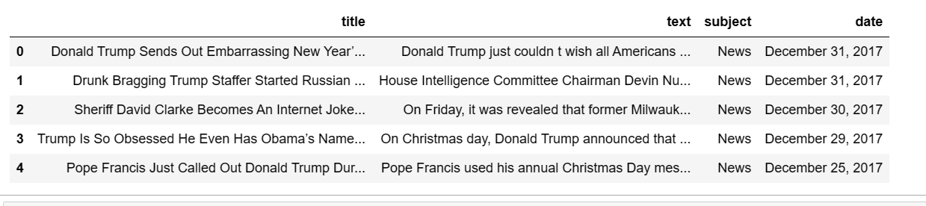

df_true.head(5)

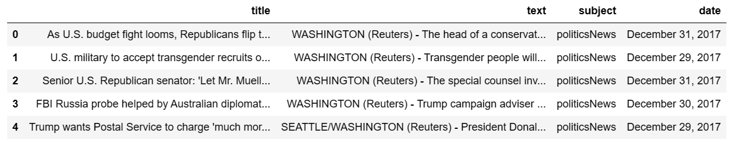

Input: Inserting a column called “class” for fake and real news dataset to categories fake and true news

df_fake["class"] = 0

df_true["class"] = 1

Input: Removing last 10 rows from both the dataset,for manual testing

df_fake.shape, df_true.shape

output: ((23481,5),(21418,5))

Input: df_fake_manual_testing = df_fake.tail(10)

for i in range(23480,23470,-1):

df_fake.drop([i], axis = 0, inplace = True)

df_true_manual_testing = df_true.tail(10)

for i in range(21416,21406,-1):

df_true.drop([i], axis = 0, inplace = True)

df_fake.shape, df_true.shape

output:(23471,5),(21408,5))

Input: Merging the manual testing dataframe in single dataset and save it in a csv file

df_fake_manual_testing["class"] = 0

df_true_manual_testing["class"] = 1

output:

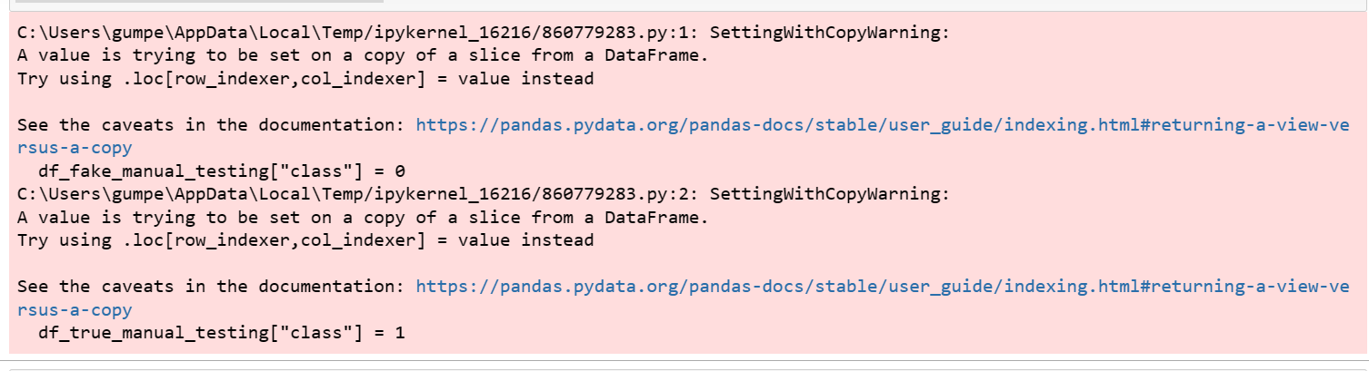

Input: df_fake_manual_testing.head(10)

Output:

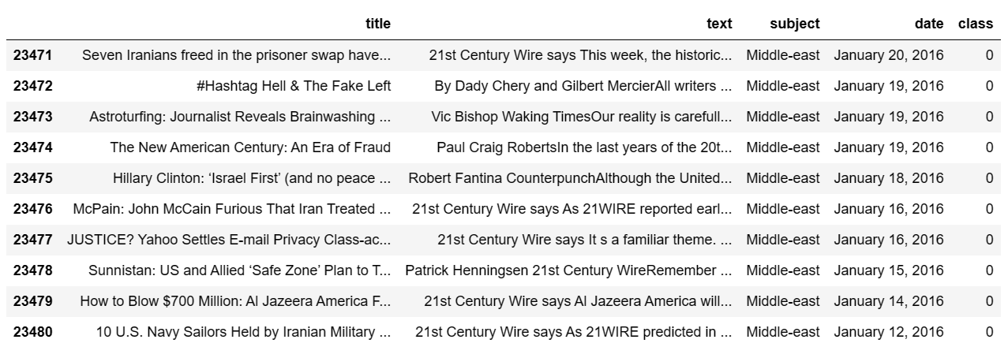

Input: df_true_manual_testing.head(10)

Output:

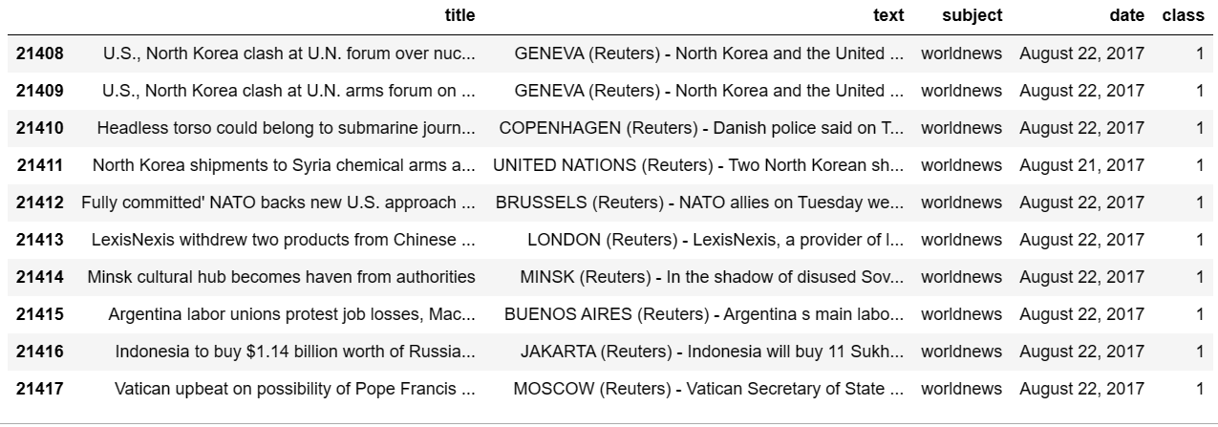

Input:

df_manual_testing =pd.concat([df_fake_manual_testing,df_true_manual_testing], axis = 0)

df_manual_testing.to_csv("manual_testing.csv")

Merging the main fake and true dataframe

df_marge = pd.concat([df_fake, df_true], axis =0 )

df_marge.head(10)

output:

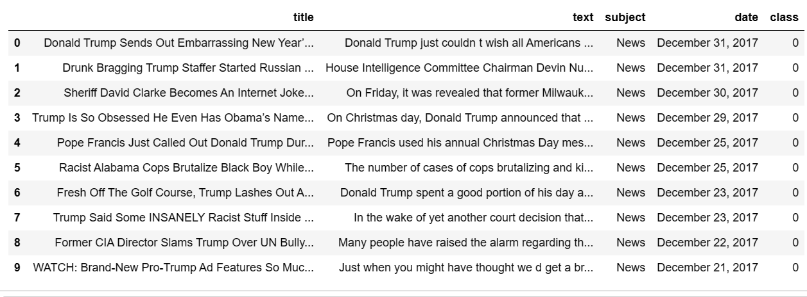

Input:df_marge.columns

Output: Index(['title', 'text', 'subject', 'date', 'class'], dtype='object')

Input: “title”,”subject”,and “date” columns is not required for detecting the fake news,so I am going to drop the column

df = df_marge.drop(["title", "subject","date"], axis = 1)

NULL Value: We will start data pre-processing with checking the null values. We need to tackle with missing values during data analysis phase. So, handling the missing values is most important aspect before starting to work on data. However, before doing anything about missing values, we need to understand the pattern of missing values occurring. The techniques are useful in the early phases of the analysis of exploratory data.

df.isnull().sum()

output: text 1

class 0

dtype: int6

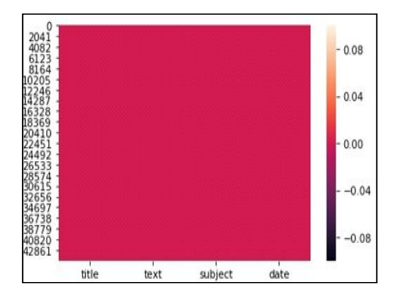

Fig:5.1.2 Heat Map

Input: Randomly shuffling the dataframe

df = df.sample(frac = 1)

df.head()

output:

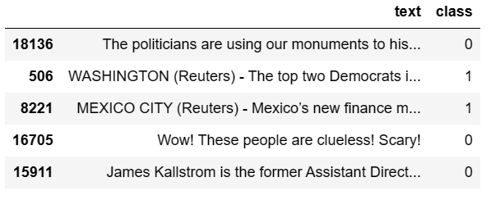

Input: df.reset_index(inplace = True)

df.drop(["index"], axis = 1, inplace = True)

df.columns

output: Index(['text', 'class'], dtype='object')

Input: df.head()

Output:

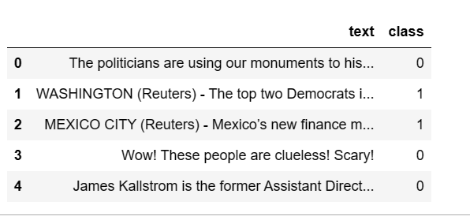

Input: Creating a function to convert the text in lowercase remove the extra space, special characters, url and links.

**5.1.3 Preprocessing**

**Tokenization:** It is a method which is used to divide the text or knowledge in a very strict singular kind of entity. It suggests that, as an example, if we tend to tokenize a text into words, then every word is going to be the tiniest entity to be processed in our logic. If we have a tendency to tokenize sentences, then every sentence is going to be the tiniest entity (or token) to be processed. However, what is the necessity of tokenization? Some of you'll say, to word tokenize the text, we are able to simply split the text by whitespaces and take away

all the punctuation marks.

**Word Stemming:** Stemming is one of the most common data pre-processing operations we do in almost all Natural Language Processing (NLP) .stemming is the process of removing a part of a word, or reducing a word to its stem or root.

**Stop Words Removal:** The words which are generally filtered out before processing a natural language are called **stop words**. These are actually the most common words in any language (like articles, prepositions, pronouns, conjunctions, etc) and does not add much information to the text. Examples of a few stop words in English are “the”, “a”, “an”, “so”, “what”.

def wordopt(text):

text =str(text).lower()

text = re.sub('\[.*?\]', '', text)

text = re.sub("\\W"," ",text)

text = re.sub('https?://\S+|www\.\S+', '', text)

text = re.sub('<.*?>+', '', text)

text = re.sub('[%s]' % re.escape(string.punctuation), '', text)

text = re.sub('\n', '', text)

text = re.sub('\w*\d\w*', '', text)

return text

df["text"] = df["text"].apply(wordopt)

Defining dependent and independent variable as x and y

x = df["text"]

y = df["class"]

Splitting the dataset into training set and testing set.

x_train, x_test, y_train, y_test = train_test_split(x, y, test_size=0.25)

**5.1.4 TF-IDF Vectorization (Feature Extraction)**

Vectorizing is the process of encoding text as integers i.e. numeric form to create feature vectors so that machine learning algorithms can understand our data.

Vectorizing Data: TF-IDF

It computes ―relative frequency that a word appears in a document compared to its frequency across all documents TF-IDF weight represents the relative importance of a term in the document and entire corpus . TF stands for Term Frequency: It calculates how frequently a term appears in a document. Since, every document size varies, a term may appear more in a long sized document that a short one. Thus, the length of the document often divides Term frequency.

TF( t, d) = Number of times t occurs in document’ d’/Total word count of document ‘d’

IDF stands for Inverse Document Frequency: A word is not of much use if it is present in all the documents. Certain terms like ‘a’, ‘an’, ‘the’ ,’on’, ‘of’ etc. appear many times in a document but are of little importance. IDF weighs down the importance of these terms and increase the importance of rare ones. The more the value of IDF, the more unique is the word

IDF(t, d)=Total number of documents/Number of documents with term t in it

TF-IDF is applied on the body text, so the relative count of each word in the sentences is stored in the document matrix.

TFIDF(t,d)=TF(t,d) * IDF(t)

convert text to vectors code

from sklearn.feature_extraction.text import TfidfVectorizer

vectorization = TfidfVectorizer()

xv_train = vectorization.fit_transform(x_train)

xv_test = vectorization.transform(x_test)

**5.1.5 Logistic Regression Model**

from sklearn.linear_model import LogisticRegression

LR = LogisticRegression()

LR.fit(xv_train,y_train)

pred_lr=LR.predict(xv_test)

LR.score(xv_test, y_test)

# Calculate the accuracy score

accuracy = accuracy_score(y_test, pred_lr)

print(classification_report(y_test, pred_lr))

# Print the accuracy score

print("Accuracy:", accuracy)

**Output:**

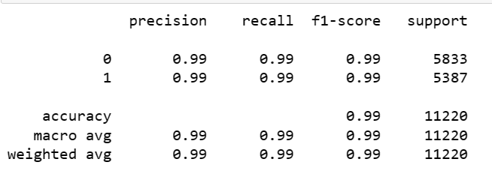

**5.1.6 Model Testing With Manual Entry**

Input:

def output_lable(news):

if news == 1:

return "True News"

elif news == 0:

return "Fake News"

def manual_testing(news):

testing_news = {"text":[news]}

new_def_test = pd.DataFrame(testing_news)

new_def_test["text"] = new_def_test["text"].apply(wordopt)

new_x_test = new_def_test["text"]

new_xv_test = vectorization.transform(new_x_test)

pred_LR = LR.predict(new_xv_test)

return print("\n\nLR Prediction: {} ".format(output_lable(pred_LR[0])))

**5.1.7 URL Search**

#URL Search

url=input("Enter the url:")

response=requests.get(url)

soup=BeautifulSoup(response.text,'html.parser')

news=soup.get_text()

print(news)

manual_testing(news)

**5.1.8 Text Search**

#Text Search

Text=str(input(“Enter the Text”))

Manual_testing(news)

**5.2 Evaluation Matrices:**

Evaluate the performance of algorithms for fake news detection problem; various evaluation metrics have been used. In this subsection, we review the most widely used metrics for fake news detection. Most existing approaches consider the fake news problem as a classification problem that predicts whether a news article is fake or not:

True Positive (TP): when predicted fake news pieces are actually classified as fake news; True Negative (TN): when predicted true news pieces are actually classified as true news; False Negative (FN): when predicted true news pieces are actually classified as fake news; False Positive (FP): when predicted fake news pieces are actually classified as true news.

**5.3 Confusion Matrix:**

A confusion matrix is a table that is often used to describe the performance of a classification model (or ―classifie) on a set of test data for which the true values are known. It allows the visualization of the performance of an algorithm. A confusion matrix is a summary of prediction results on a classification problem. The number of correct and incorrect predictions are summarized with count values and broken down by each class. This is the key to the confusion matrix. The confusion matrix shows the ways in which your classification model is confused when it makes predictions. It gives us insight not only into the errors being made by a classifier but more importantly the types of errors that are being made

By formulating this as a classification problem, we can define following metrics

1. Precision = |T P| */* |T P|+|F P|

2. Recall = |T P| / |T P| + |F N|

3. F1 Score = 2 * precision * Recall / precision + Recall

4. Accuracy=|T P|+|T N|/|T P|+|T N|+|F P|+|F N|

**5.4 output Screenshots:-**

**5.4.1 When we enter input as url**

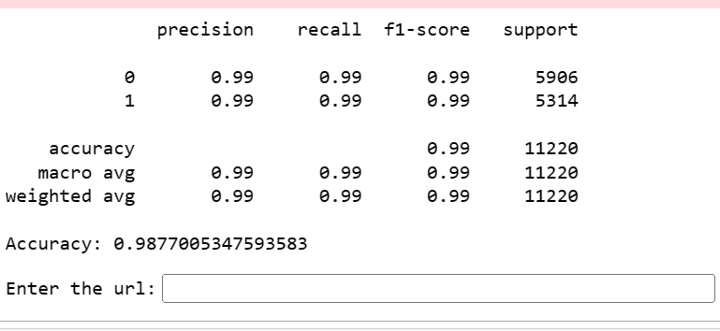

**Output as True news:**

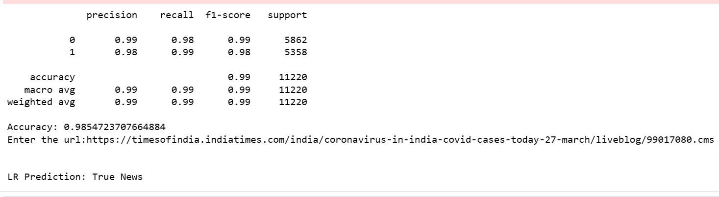

**Output as Fake news:**

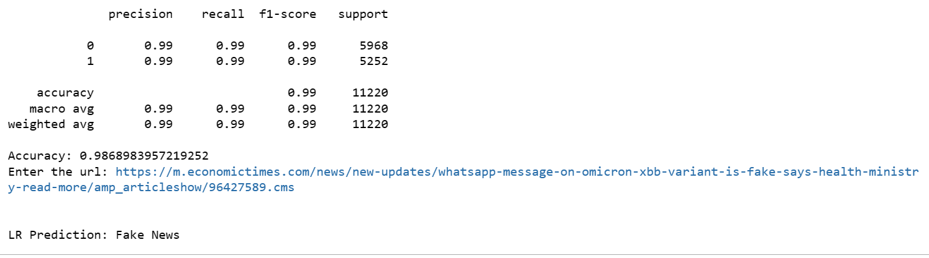

**5.4.2 When we enter input as text**

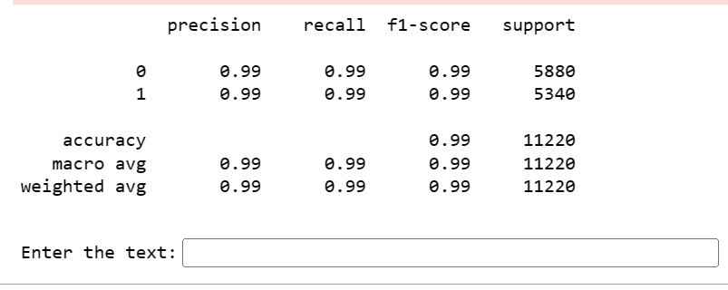

**Output as True news:**

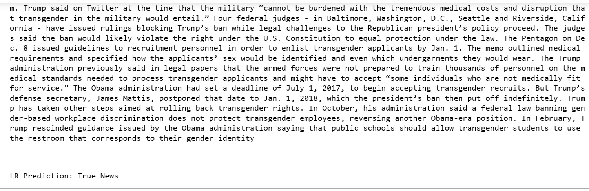

**Output as Fake news:**

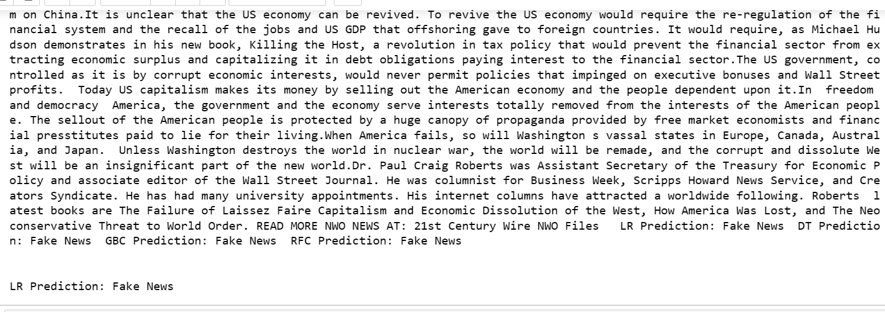

5.4.3 Figure shows topic wise distribution of the news data. From the plot it is clear that we have got a greater number of instances on political news. In order to take into account, the title in our accuracy prediction, we created an extra column that combines text and title. We will not do separate predictions on the title, since it might classify as e. g. fake news, weather the actual text with more explanation tells a real story. After pre-processing the representation of the dataset with respect to different categories is depicted

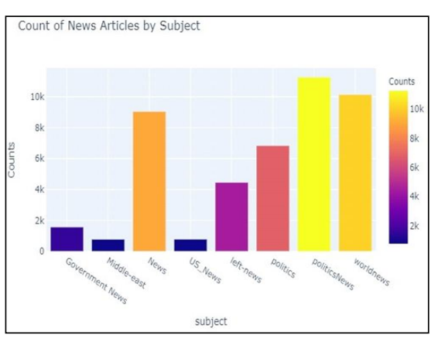

Fig:5.4.3 Topic wise distribution of news data

**6.BASE PAPERS**



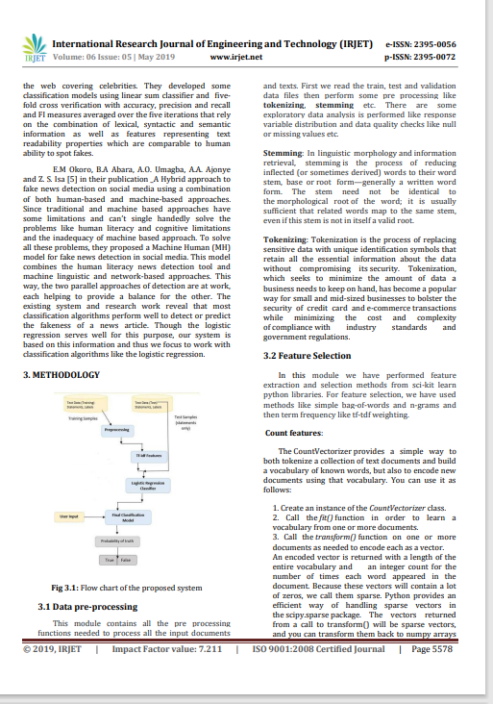

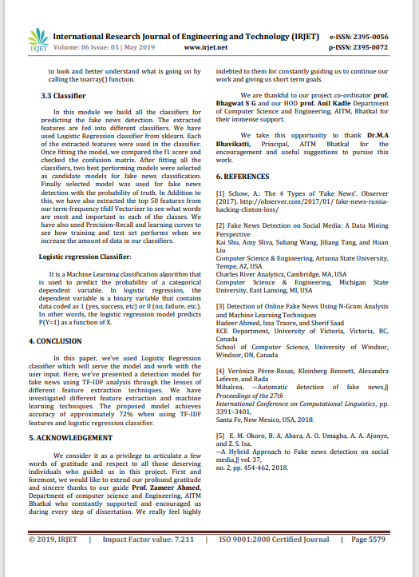

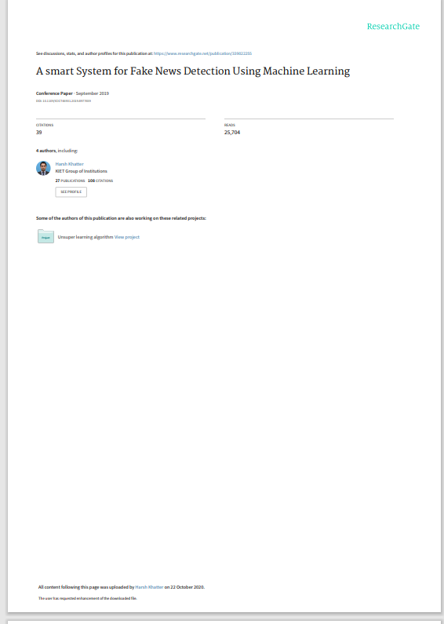

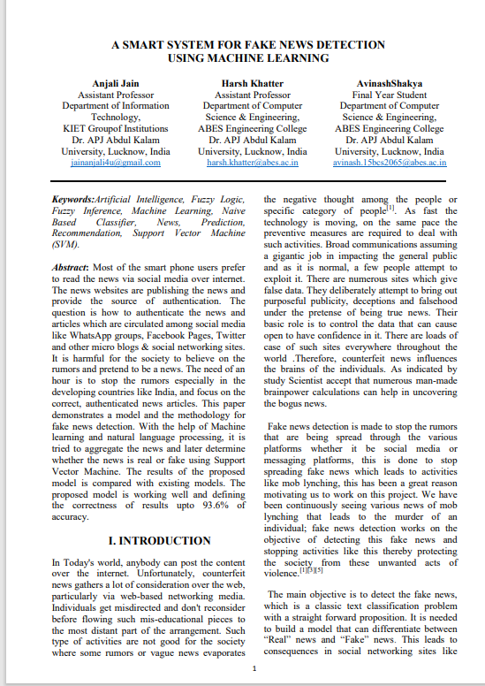

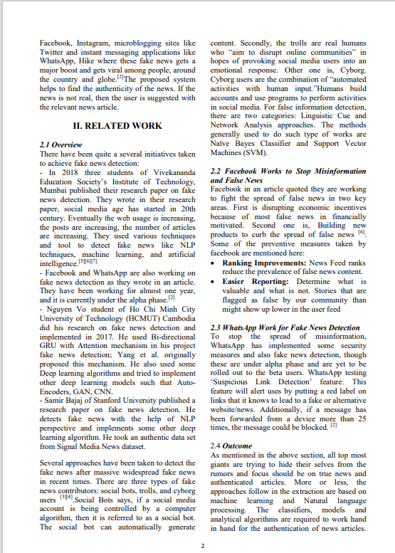

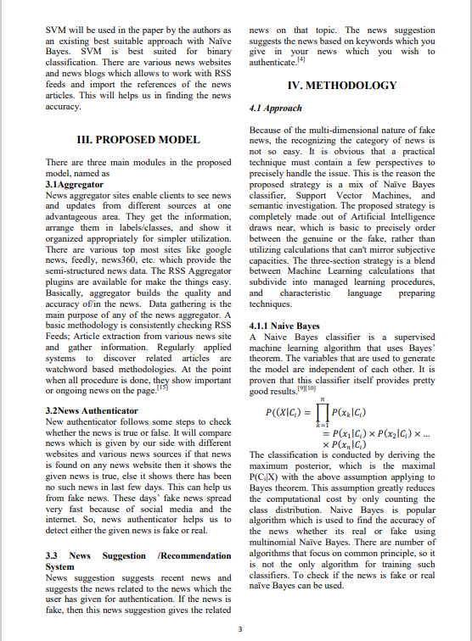

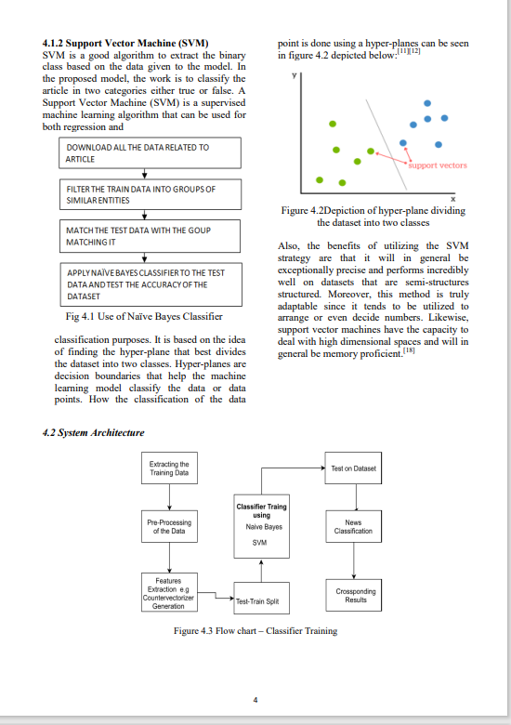

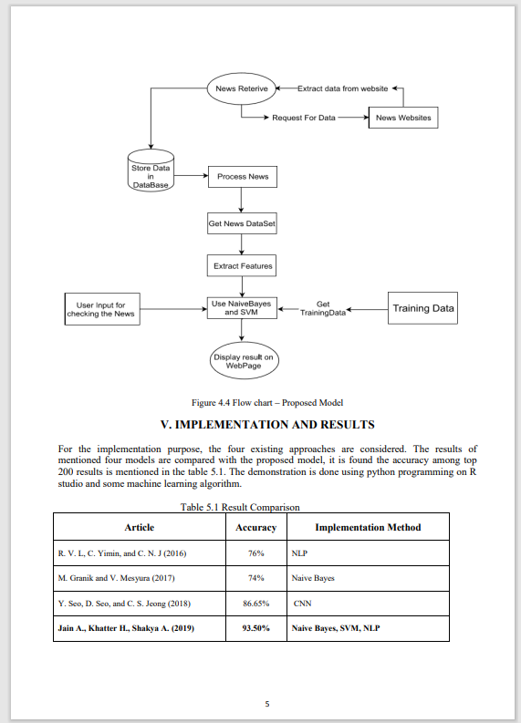

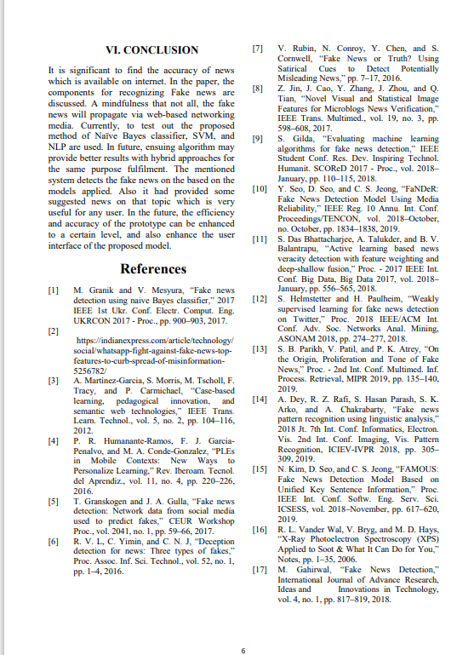

**7.Power Point Presentation Slides**





















**CONCLUSION**

As social media is continuously growing, more people easily get news through social media as compared to traditional forms of news mediums. Networking though online modes now used to spread distorted news, which may lead to significant or adverse effects on consumers side and wider to the community. Through this work, a technique is proposed where in there is a combination of two different approaches for achieving improved accuracy in recognition of fake news.we looked at a computerized model for verifying news extracted from social media, which provides expository demonstrations for recognizing fake news. Following the demonstration that even the most basic algorithms in domains of Machine Learning can produce a reasonable result on such a critical issue as the spread of fake news around the world. As a result, the findings of this investigation suggest that systems like this could be very useful and effective in dealing with this critical issue. Web scraping is used in the project as the scraped data will be based on real-time news and will be more reliable than the ready-made datasets available all over the internet. It is an efficient and fast process and also it is very easy to maintain. The dataset used in this study is expected to be used in arrangements that use machine learning-based statistical calculations of Logistic Regression (LR). This approach uses effective data cleaning and categorization which helps in improved accuracy. The web scraping module is combined with classification module further improves the accuracy of the approach. Both of these modules work in parallel therefore, the overall training time is reduced.

**BIBLIOGRAPHY**

[1] K. Shu, A. Sliva, S. Wang, J. Tang, and H. Liu, “Fake news detection on social media: A data mining perspective,” SIGKDD Explor. Newsl., vol. 19, no. 1, sep 2017.

[2] [(PDF) Fake News Identification Using Regression Analysis and Web Scraping (researchgate.net)](https://www.researchgate.net/publication/362235353_Fake_News_Identification_Using_Regression_Analysis_and_Web_Scraping)

[3] Fake News Detection using Machine Learning Algorithms Uma Sharma, Sidarth Saran, Shankar M. Patil Department of Information Technology Bharati Vidyapeeth College of Engineering Navi Mumbai, India.

[4] FAKE NEWS DETECTION USING LOGISTIC REGRESSION Fathima Nada1, Bariya Firdous Khan2, Aroofa Maryam3, Nooruz-Zuha4, Zameer Ahmed 1,2,3,4Anjuman Institute of Technology and Management , Bhatkal 5Under the guidance of (Professor of Computer Science and Engineering department AITM, Bhatkal).

[5] Fake News Detection using Machine Learning Prasad Kulkarni1,? , Suyash Karwande1,?? , Rhucha Keskar1,??? , PrashantKale1,????, and Sumitra Iyer1 1Electronics and Telecommunication Department, SIES, Graduate School of Technology, Navi Mumbai, India.

[6] A SMART SYSTEM FOR FAKE NEWS DETECTIONUSING MACHINE LEARNINGhttps://www.researchgate.net/publication/339022255_A_smart_System_for_Fake_News_Det ection_Using_Machine_Learning.

[7] Granik, Mykhailo, and Volodymyr Mesyura. "Fake news detection using naive Bayes classifier." In 2017 IEEE First Ukraine Conference on Electrical and Computer Engineering (UKRCON), pp. 900-903. IEEE, 2017.

[8] M. Granik and V. Mesyura, “Fake news detection using naive Bayes classifier,” 2017 IEEE 1st Ukr. Conf. Electr. Comput. Eng. UKRCON 2017 - Proc., pp. 900–903, 2017.

[9] Kai Shu, Amy Sliva, Suhang Wang, Jiliang Tang, and Huan Liu, ―Fake News Detection on Social Media: A Data Mining Perspective.

[10] Schow, A.: The 4 Types of ‘Fake News’. Observer (2017). http://observer.com/2017/01/ fake-news-russiahacking-clinton-loss/